## Composite DP for Library class:

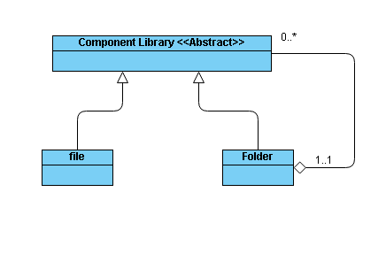

Figure6: Library Class Diagram

## Strategy DP for Workspace class:

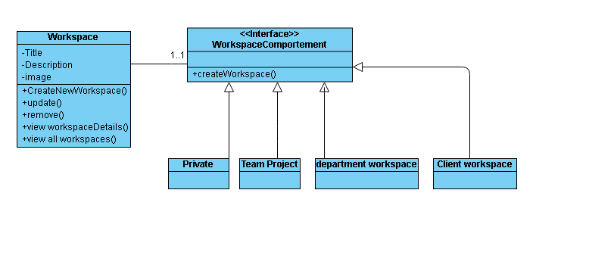

Fifure6: Workspace Class Diagram

## Strategy DP for Collaborator class:

